Imaginary User Student researcher:

This user is highly experienced with different UI’s and doesn’t need much instruction on what to do the get antiquated with the system. The reason they’re using the software is because they seek to gain a more fundamental understanding of the dataset that they’ve acquired. They also want to test the limits of current software to push their research forward by great leaps and bounds. They are highly motivated and will put a reasonably high level of energy forward when using something new if it produces results after the initial learning curve has been climbed.

Imaginary User Faculty advisor:

This user is using the software for instruction purposes to help their advises make progress with their research goals. They have reasonable experience with different UI’s but aren’t willing to put forth herculean efforts in the name of being able to use a fancy software package. What they want is something that will help them guide their student collaborators forward and easily share new things that both parties have learned. For them obedience to standard UI conventions is a requirement so that the tool in question doesn’t get in the way of work.

Imaginary User Older grant financer:

This user is being exposed to the software because their deciding whether based on the data they’ve been sent if it warrants substantial financing or not. They are from an older generation that doesn’t want to take the time to learn different a software framework and as such they only like things that are relatable and intuitive. They also dislike it when the tool they are using has exceedingly small font, because it becomes significantly harder for them to read. They would prefer relatable graphics where appropriate because it require less reading and thinking.

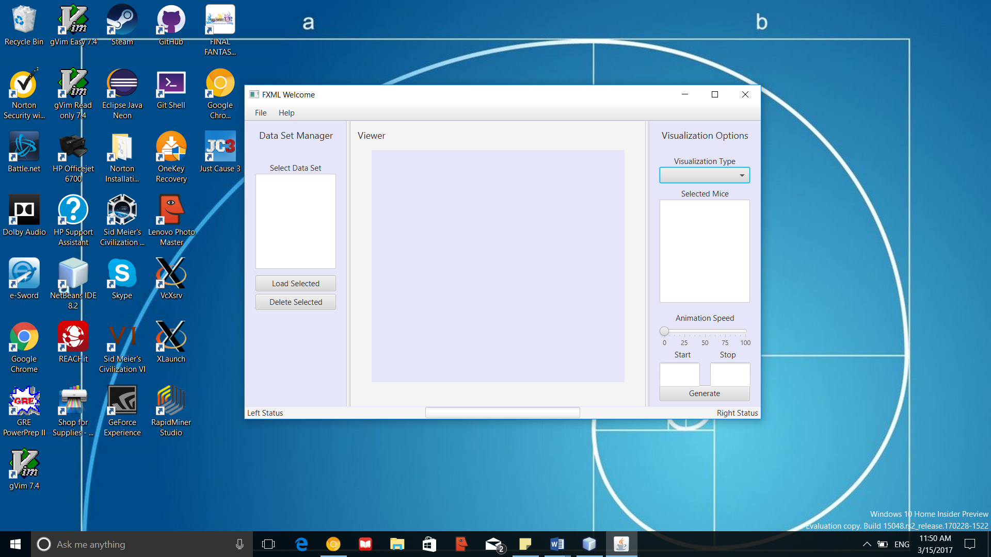

Feedback:

1. Clean interface without distractions. Feels like it’s meant for scientific applications. The layout seems intuitive enough with a little practice on what should do what.
2. The interface looks from an untrained eye pretty self explanatory. You can see where the mouse position would be on a viewer window, select a mouse and see where it is from one time point to another. A new user could figure out how to work the system pretty fast.

Functions:

The mouse visualization tool is designed for aiding in the understanding of experimental data from mouse experiments. Its primary functions are to take a dataset of mouse positions and create visualizations or animations of the dataset based on the data fed into the system. The visualization options available to the user will be generating a heat map, vector map or heat-vector overlay map. In terms of animation options, it will allow the user to decide if they want to animate the motions of the mice in the study. The other important feature is the system will produce a sorted version of the dataset and enable users to create PDFs or JPEGs of visualizations produced during their session. These two features are useful if the user decides they want to export any information generated in their session to another user or software tool.

Reading this, the user should be able to obtain a file or files of experiments conducted on mice and will allow them to get a useable version of a map and will have the sorted list of experiments to use with other tools.

This tool will take different positions of mice and create the visualizations/animations of these mice movement based on the information that is inputted into the system. The user can select for the visualization to create 3 different maps and will also allow the user to create PDFs/JPEGS of these visualizations created during their data input session. This will allow the user to take their generated map and import it into another tool or send it to another user.

I’m expecting after reading this that the user will just have to lick a button jor use a shortcut to

create the export and choose from a context menu which type and style of file to export

This tool will generate a visual map that can be animate or static based on the movements of mice and the information that is inserted into the system.

The export to PDF/JPEG function would take the heatmap, vector map, or heat-vector overlay map currently rendered in the application and save an image of it as a PDF or JPEG. If it has animations, and the user selects to export to JPEG, then the animations will also be captured using the new MJPEG format.

// The program will export a .pdf containing the information listed above

// The user will click an export button and be given options of what data they want to export. Once they specify the data they want to export, they will be asked how they want it exported, either as a heat map, vector map, or heat-vector map. They will then be asked if they want their exported data to be animated or not. They will then be asked if they want it as a PDF or JPEG. They will then be given their exported data to be downloaded.